How to create cfg file:
Step 1: Generate .rdd, .mdd, and .edd files
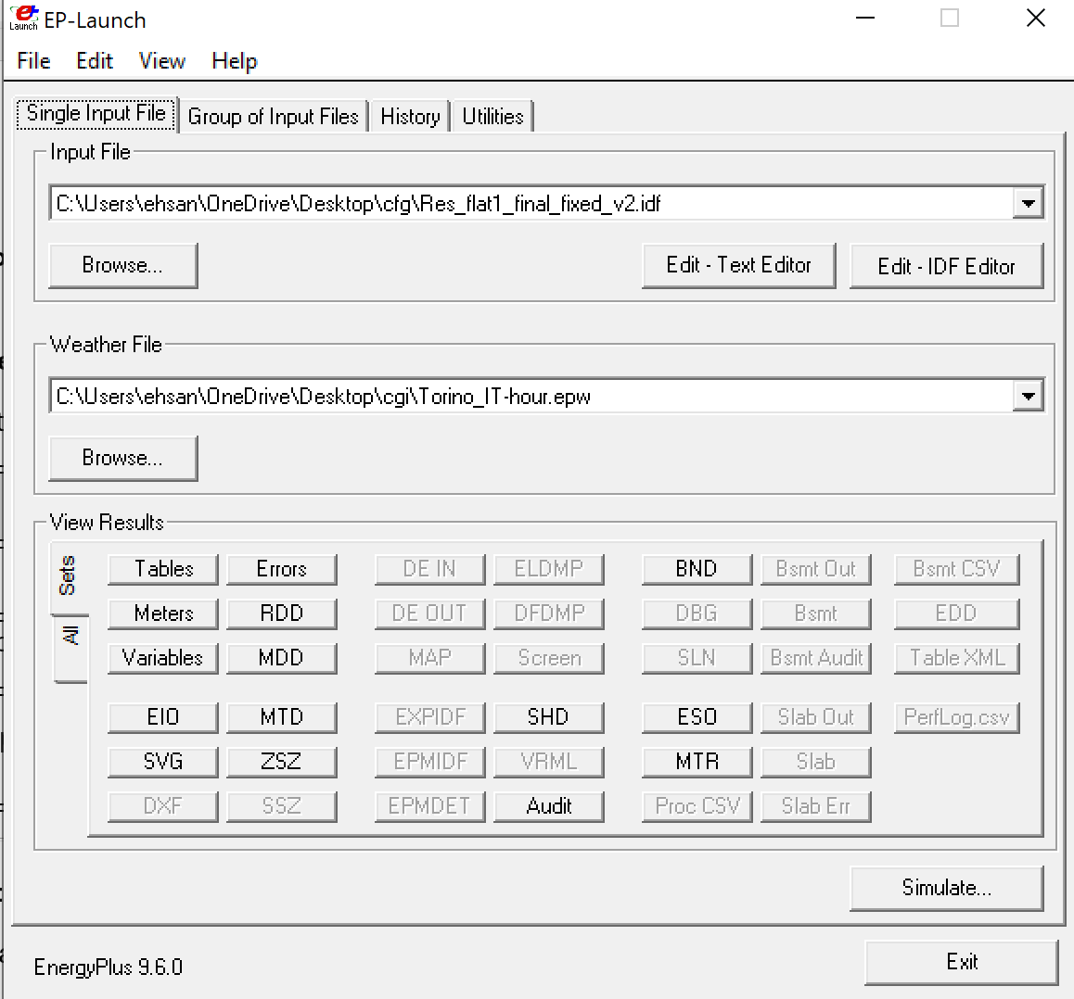
After your first EnergyPlus simulation, these three files appear in the output directory:
File | Description
eplusout.rdd | All available output variables (Output:Variable)
eplusmtr.mdd | All available meter variables (Output:Meter)
eplusout.edd | Lists all EMS-compatible actuators with component name/type/control type
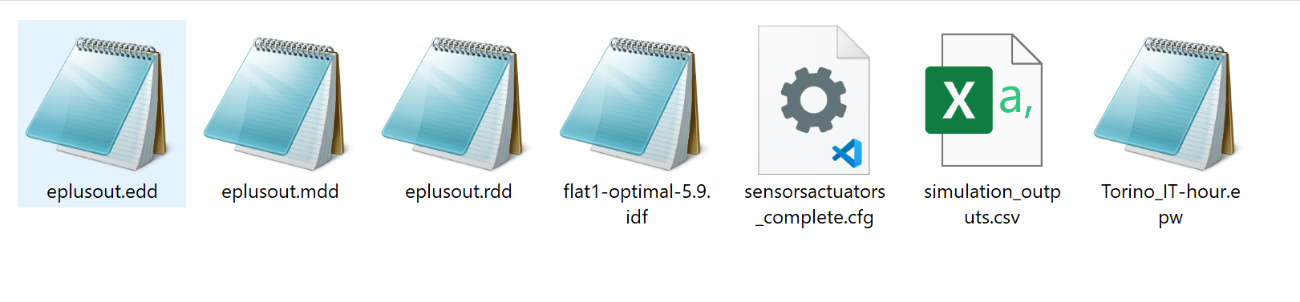

Step 2: Pick sensors from .rdd and .mdd
Example sensor variables:
- Zone Mean Air Temperature
- Zone Operative Temperature
- Zone Air Relative Humidity
- Electricity:Facility (from .mdd, meter = true)

Step 3: Pick actuators from .edd
You will find entries like:
Component Name = BLOCCO1:ZONA2
Component Type = Zone Temperature Control
Control Type = Cooling Setpoint
Use these three to define actuators in your config.

Step 4: Write the JSON config (cfg) file
Based on the .rdd, .edd, and .mdd findings, structure your config like this:
json
CopyEdit
{
"sensors": [...],
"actuators": [...]
}

Generating an FMU from an EnergyPlus Model Using Docker on Windows
1. Introduction
Energy modeling is a crucial step in analyzing the thermal and energy performance of buildings. EnergyPlus, a powerful simulation engine developed by the U.S. Department of Energy, allows for detailed simulation of building systems and performance. In order to integrate an EnergyPlus model with external controllers (e.g., for co-simulation with Python, MATLAB, or reinforcement learning agents), the model must be exported as a Functional Mock-up Unit (FMU) that adheres to the FMI 2.0 standard.
Since the official EnergyPlusToFMU tool only supports Linux, this project utilizes Docker in Windows to create a Linux container environment in which the conversion from IDF to FMU can be performed seamlessly.
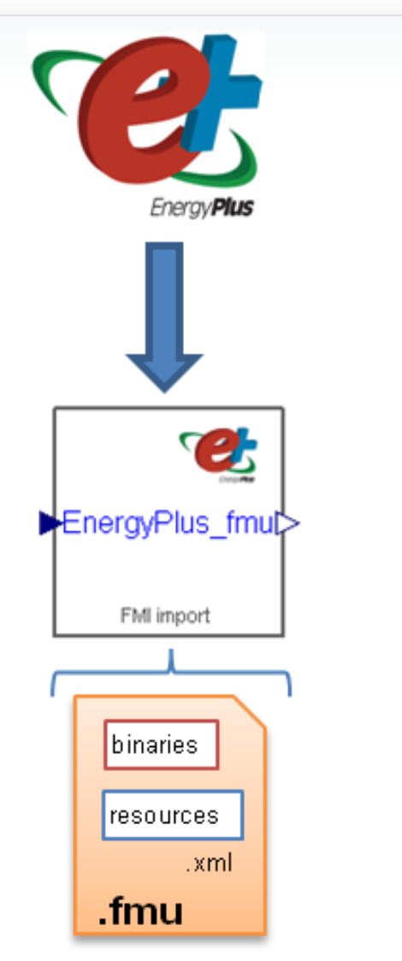

2. Tools and Required Files
Software Components
- Docker Desktop (on Windows)
- EnergyPlus 9.6.0 for Linux (installer)
- EnergyPlusToFMU v3.1.0
- Python 3.x (inside the container)
Required Files
File Name | Description
flat1.idf | EnergyPlus input model (building definition)
weather.epw | EPW weather file (for Torino, Italy)
sensorsactuators_complete.cfg | JSON configuration of sensors and actuators
fix_idf.py | Python script to modify IDF for FMU compatibility
EnergyPlus-9.6.0-Linux-Ubuntu.sh | Linux installer for EnergyPlus 9.6
EnergyPlusToFMU-v3.1.0.zip | Official FMU export tool from LBNL

3. Procedure
3.1 Project Directory Setup
A working directory named energyplus_fmu was created at:
makefile
C:\Users\ehsan\OneDrive\Documents\ICT\Building\project\our project\energyplus_fmu
All required files listed above were placed in this folder.
3.2 Creating the Dockerfile
A custom Dockerfile was written to build a Linux-based container with all dependencies pre-installed. This includes EnergyPlus 9.6.0 and the EnergyPlusToFMU tool. The working directory inside the container was set to /workspace.
3.3 Building the Docker Image
The image was built from the terminal using:
powershell
docker build -t eplus-fmu
This command generated a Docker image named eplus-fmu.
3.4 Running the Container
The container was started with access to the local project folder:
powershell
docker run -it --rm -v "${PWD}:/workspace" eplus-fmu
Inside the container, the /workspace directory mirrors the Windows folder.
3.5 Preparing the IDF File
A custom Python script fix_idf.py was executed to enhance the original IDF file with the following components:
- ExternalInterface block
- Output:Variable objects for sensors
- ExternalInterface:From for sensor export
- ExternalInterface:To for actuator import
The modified file was saved as flat1-fmu.idf.
3.6 FMU Conversion
The FMU was created using the following command from the tool's directory:
bash
cd /opt/EnergyPlusToFMU
python Scripts/EnergyPlusToFMU.py \
-i /usr/local/EnergyPlus-9-6-0/Energy+.idd \
-w /workspace/weather.epw \
-a 2 \
/workspace/flat1-fmu.idf
The result was a .fmu file containing the model and interface configuration, ready for co-simulation.
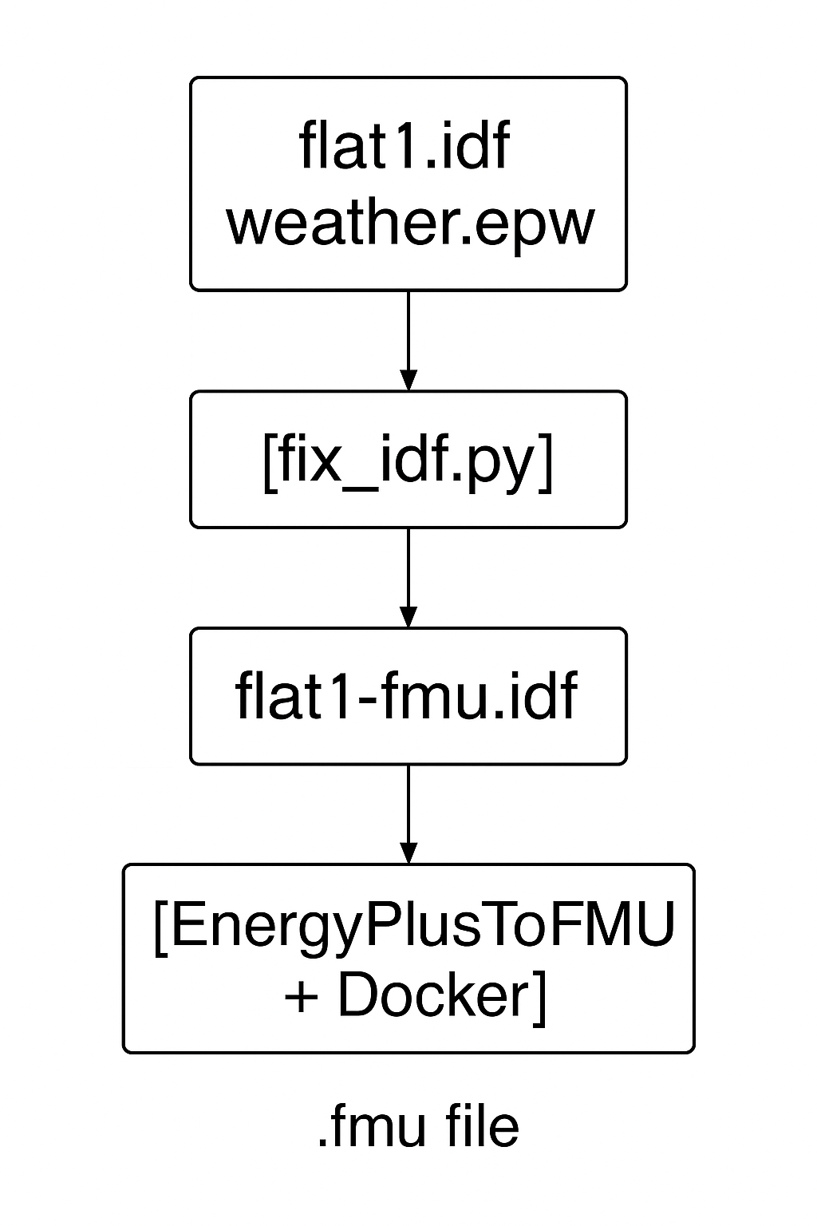

FMU Validation Using FMPy
After generating the .fmu file, we validated its structure and contents using the FMPy Python library. The FMU was extracted and the modelDescription.xml file was parsed to inspect variable names, causality, and types.
Python Code Snippet:
from fmpy import extract, read_model_description
import os

# مسیر فایل FMU
fmu_path = '/content/drive/MyDrive/flat1_optimal_5_9_fmu_fixed.fmu' # اگر روی گوگل درایو هست، مسیر کامل بده

# مرحله 1: استخراج FMU در پوشه موقت
extracted_dir = extract(fmu_path)
print("✅ FMU extracted to:", extracted_dir)

# مرحله 2: خواندن فایل modelDescription.xml از مسیر درست
model_desc_path = os.path.join(extracted_dir, 'modelDescription.xml')
desc = read_model_description(model_desc_path)

print(f"\n📄 Model name: {desc.modelName}")
print("🔍 Variable List (Name | Causality | Type):\n")

for v in desc.modelVariables:
print(f"- {v.name:45} | {v.causality:6} | {v.type}")
Output:
BLOCCO1:ZONA1_HeatingSetpoint | input | Real
- BLOCCO1:ZONA1_CoolingSetpoint | input | Real
- BLOCCO1:ZONA2_HeatingSetpoint | input | Real
- BLOCCO1:ZONA2_CoolingSetpoint | input | Real
- BLOCCO1:ZONA3_HeatingSetpoint | input | Real
- BLOCCO1:ZONA3_CoolingSetpoint | input | Real
- BLOCCO1:ZONA4_HeatingSetpoint | input | Real
- BLOCCO1:ZONA4_CoolingSetpoint | input | Real
- BLOCCO1:ZONA5_HeatingSetpoint | input | Real
- BLOCCO1:ZONA5_CoolingSetpoint | input | Real
- BLOCCO1:ZONA6_HeatingSetpoint | input | Real
- BLOCCO1:ZONA6_CoolingSetpoint | input | Real
- BLOCCO1:ZONA7_HeatingSetpoint | input | Real
- BLOCCO1:ZONA7_CoolingSetpoint | input | Real
- BLOCCO1:ZONA1_MeanAirTemp | output | Real
- BLOCCO1:ZONA1_OperativeTemp | output | Real
- BLOCCO1:ZONA1_RelHumidity | output | Real
- BLOCCO1:ZONA1_HeatingEnergy | output | Real
- BLOCCO1:ZONA1_CoolingEnergy | output | Real
- BLOCCO1:ZONA1_PeopleCount | output | Real
- BLOCCO1:ZONA2_MeanAirTemp | output | Real
- BLOCCO1:ZONA2_OperativeTemp | output | Real
- BLOCCO1:ZONA2_RelHumidity | output | Real
- BLOCCO1:ZONA2_HeatingEnergy | output | Real
- BLOCCO1:ZONA2_CoolingEnergy | output | Real
- BLOCCO1:ZONA2_PeopleCount | output | Real
- BLOCCO1:ZONA3_MeanAirTemp | output | Real
- BLOCCO1:ZONA3_OperativeTemp | output | Real
- BLOCCO1:ZONA3_RelHumidity | output | Real
- BLOCCO1:ZONA3_HeatingEnergy | output | Real
- BLOCCO1:ZONA3_CoolingEnergy | output | Real
- BLOCCO1:ZONA3_PeopleCount | output | Real
- BLOCCO1:ZONA4_MeanAirTemp | output | Real
- BLOCCO1:ZONA4_OperativeTemp | output | Real
- BLOCCO1:ZONA4_RelHumidity | output | Real
- BLOCCO1:ZONA4_HeatingEnergy | output | Real
- BLOCCO1:ZONA4_CoolingEnergy | output | Real
- BLOCCO1:ZONA4_PeopleCount | output | Real
- BLOCCO1:ZONA5_MeanAirTemp | output | Real
- BLOCCO1:ZONA5_OperativeTemp | output | Real
- BLOCCO1:ZONA5_RelHumidity | output | Real
- BLOCCO1:ZONA5_HeatingEnergy | output | Real
- BLOCCO1:ZONA5_CoolingEnergy | output | Real
- BLOCCO1:ZONA5_PeopleCount | output | Real
- BLOCCO1:ZONA6_MeanAirTemp | output | Real
- BLOCCO1:ZONA6_OperativeTemp | output | Real
- BLOCCO1:ZONA6_RelHumidity | output | Real
- BLOCCO1:ZONA6_HeatingEnergy | output | Real
- BLOCCO1:ZONA6_CoolingEnergy | output | Real
- BLOCCO1:ZONA6_PeopleCount | output | Real
- BLOCCO1:ZONA7_MeanAirTemp | output | Real
- BLOCCO1:ZONA7_OperativeTemp | output | Real
- BLOCCO1:ZONA7_RelHumidity | output | Real
- BLOCCO1:ZONA7_HeatingEnergy | output | Real
- BLOCCO1:ZONA7_CoolingEnergy | output | Real
- BLOCCO1:ZONA7_PeopleCount | output | Real

Result:
- Model successfully extracted
- Variables correctly listed with proper input/output causality
- Confirmed alignment with the configured sensors and actuators
This ensures the FMU is correctly structured and ready for co-simulation.

4. Conclusion
By using Docker, we successfully generated an FMU from an EnergyPlus model within a Windows environment, bypassing the native Linux-only restrictions of the EnergyPlusToFMU tool. This method enables integration with advanced controllers, allows for scalable deployment, and supports real-time simulation frameworks. The FMU can now be used for smart control experiments, such as reinforcement learning-based HVAC regulation or model predictive control (MPC).
This workflow is portable, reproducible, and ideal for research in building energy management and smart grid co-simulation.

